

**SERVICES**

**The Praetors**

CONTENTS

1 SOFTWARE DEVELOPMENT 2

2 ANDROID APP DEVELOPMENT 12

3 IOS APP DEVELOPMENT 21

# SOFTWARE DEVELOPMENT

**META TITLE**: Custom Software Development Services | The Praetors

**META DESCRIPTION**: Discover tailored software solutions for your business needs. Experience seamless integration & ongoing support with your reliable custom software application development company!

**URL**:

**[BANNER 1]**

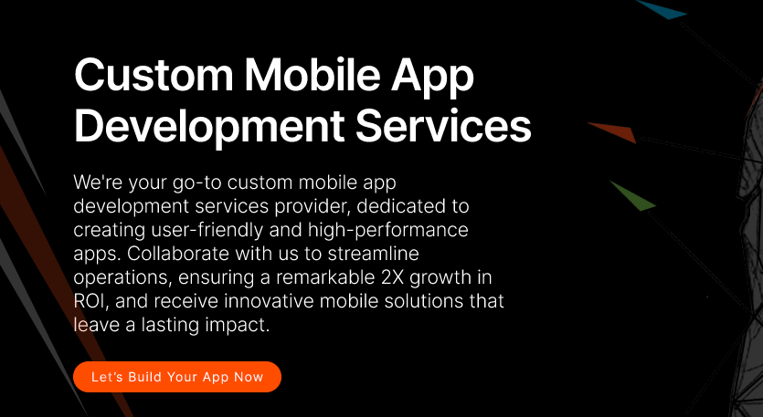

**Custom Software Development Services**

Empower your business with our resilient, safeguarded, and adaptable bespoke software offerings. Our customized solutions are engineered to fortify your operations, ensuring reliability and growth. We specialize in crafting custom software solutions that seamlessly integrate with your unique requirements, providing a secure foundation for your digital endeavors. Trust us to deliver scalable solutions that evolve with your business, propelling you towards sustained success in today’s dynamic landscape.

**[LET’S BUILD YOUR SOFTWARE NOW]**

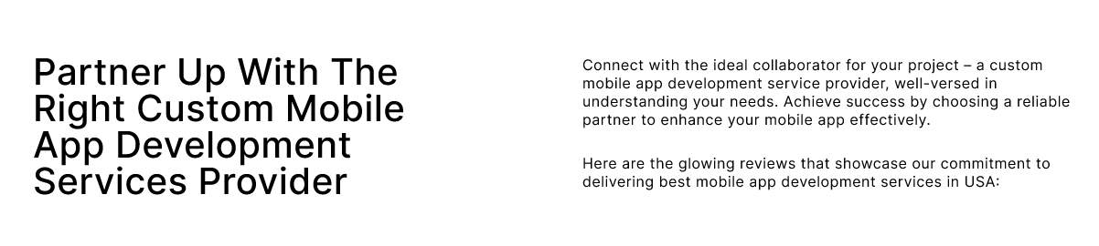

**Personalized And Pre-Packaged Software Development Solutions For Your Unique Business Needs**

An industry-leading custom software development company, The Praetors leads the charge in custom software development and digital innovation. We partner with global enterprises and startups alike to deliver top-notch solutions. Our comprehensive software services cover the entire development spectrum, from inception to deployment, ensuring robust security and seamless maintenance.

Whether it's enhancing existing platforms, pioneering prototype applications, or architecting sophisticated enterprise solutions, our diverse team of experts is strategically positioned worldwide to deliver swift, reliable software development solutions.

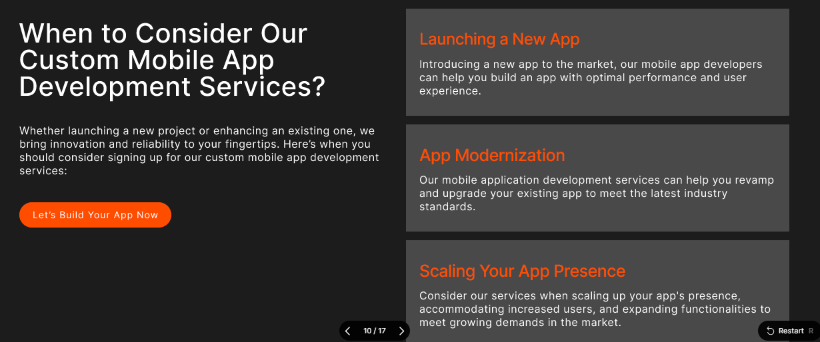

**Gain the Edge with Our Bespoke, AI-First Software Product Development Services** Top of Form

With decades of invaluable experience and deep-rooted industry-specific expertise, we enable organizations to spearhead innovation and cultivate sustainable growth. Our bespoke approach emphasizes the integration of cutting-edge artificial intelligence technologies, positioning businesses to navigate and excel within the dynamic currents of modern industry.

With The Praetors’ custom software development, you can reap the benefits including but not limited to streamlined operations, enhanced productivity, actionable insights, improved customer experiences, and future-proof technology solutions.

|  |  |
| --- | --- |
| **Engineering Excellence** | Built on design-driven principles and a product-centric mindset, our solutions seamlessly integrate with business operations and scale effortlessly, ensuring innovation and adaptability at every turn. |
| **Agile Development** | Adopting an agile methodology, we offer enhanced control, flexibility, and risk mitigation throughout the development lifecycle, accelerating time to market and maximizing return on investment. |
| **Operational Efficiency** | Utilizing offshore, nearshore, and blended shore capabilities, we leverage time zone variances to our advantage, providing round-the-clock development and support services for unmatched operational efficiency and customer satisfaction. |

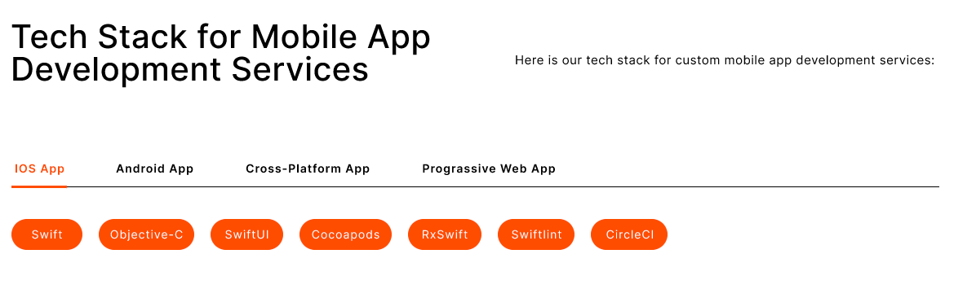

**Innovative Software Development Solutions, Driven by Dynamic Tech Stacks**

We offer custom software products powered by state-of-the-art technology.

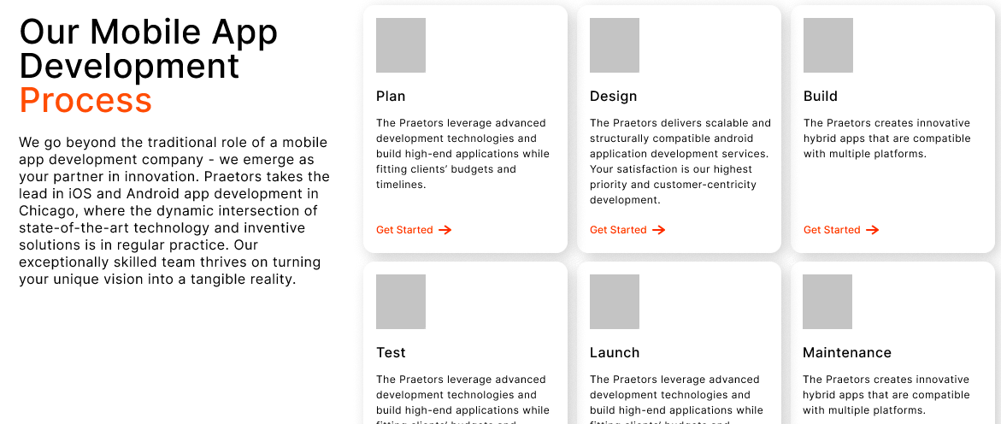

**Discover Our Methodical Software Development Process**

Our custom software development process is carefully structured, with a primary focus on personalized user experiences and the creation of exceptionally efficient solutions. Through our comprehensive range of services, we establish a transparent and dependable partnership, ensuring the delivery of impactful and groundbreaking software solutions. With our experienced guidance and never-ending dedication, you can trust us to navigate every aspect of the journey professionally and precisely, driving forward transformative results for your business.

|  |  |
| --- | --- |
| **Discovery** | We begin by understanding your needs and goals and gathering essential information to lay the foundation for our collaboration. |
| **Planning** | With a clear understanding, we develop a detailed plan outlining the scope, timeline, and resources required for the project. |
| **Design** | Our team creates intuitive, user-friendly designs, ensuring the software aligns seamlessly with your vision and objectives. |
| **Development** | Our skilled custom software developers bring the designs to life, meticulously coding and building the software according to the outlined specifications. |
| **Testing** | Rigorous testing procedures are conducted to identify and resolve any issues, ensuring the software meets high quality and functionality standards. |
| **Launch** | Once thoroughly tested and approved, we deploy the software, providing comprehensive support and guidance to ensure a smooth transition and optimal performance. |

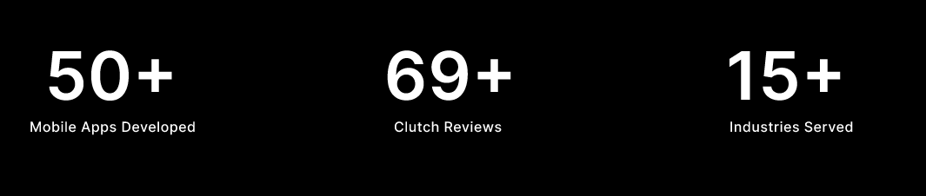

|  |  |  |
| --- | --- | --- |
| **2+**  **Decades of Experience** | **137K+**  **Clients Globally** | **350K+**  **Digital Products Delivered** |

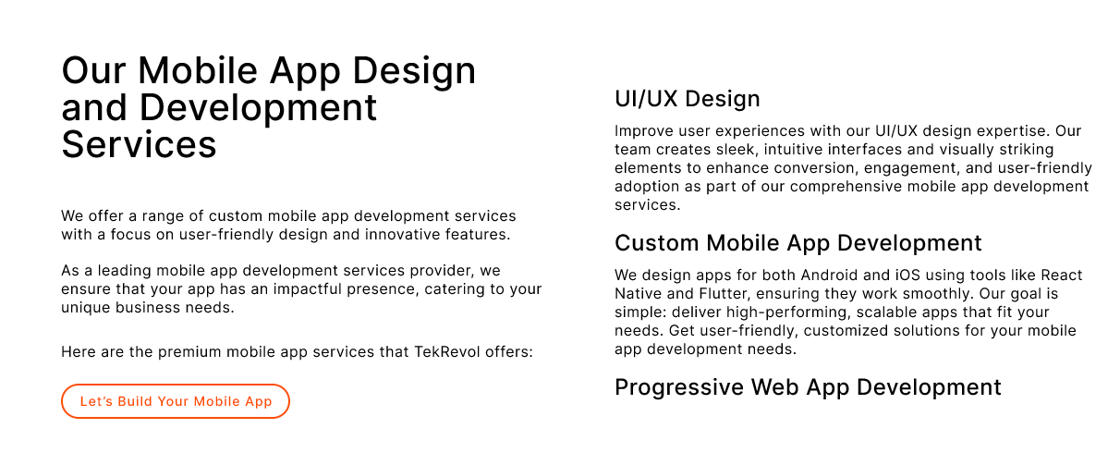

**Our Custom Software Development Services**

The Praetors offers extensive enterprise-level software development solutions to strengthen your business's digital evolution.

With our expert services, we expedite the process of adopting technological advancements to enhance your operational efficiency and competitive edge in the modern landscape.

Trust in our proficiency to tailor innovative software solutions that cater precisely to your unique business requirements and drive tangible results for your organization's growth and success.

|  |  |
| --- | --- |
| **Enterprise Software Solutions**  Designed for efficiency and growth, these solutions optimize operations across various departments, ensuring scalability and seamless integration with existing systems. With a focus on reliability and performance, our software empowers businesses to adapt to evolving demands and drive sustainable success in today's dynamic market landscape. | **Software Prototyping**  Accelerate your product development process with our software prototyping. By quickly creating and testing functional prototypes, we help minimize risks and validate ideas before committing to full-scale development. With rapid iteration and feedback loops, our prototyping approach enables you to bring innovative products to market faster and more confidently. |
| **Web Application Development**  From simple websites to complex web applications, our team leverages the latest technologies and industry best practices to create engaging digital experiences for your target audience. With a focus on usability and performance, we ensure that your web applications meet the highest standards of quality and functionality. | **Cloud-based Software Solutions**  By migrating your applications and data to the cloud, you gain access to scalable infrastructure, enhanced flexibility, and cost-effective IT resources. Our team of cloud experts will work closely with you to design and implement cloud solutions, enabling you to innovate and grow confidently in the digital age. |

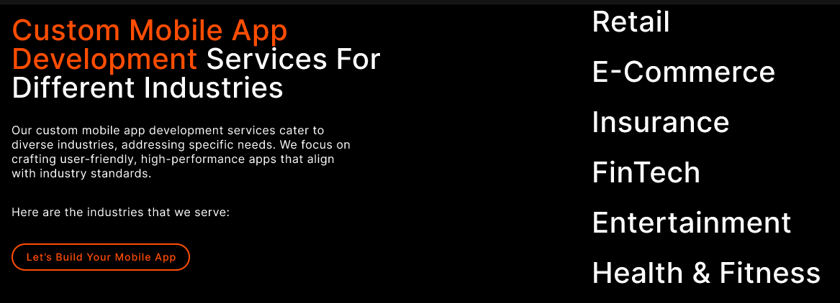

**From Healthcare to Finance: Our Custom Software Development Expertise Knows No Bounds!**

As a custom software development company with an expert team equipped with pro-level skills and the latest tech, we work diligently to understand your requirements and employ advanced digital tools and techniques to deliver effective solutions that deliver positive results.

Trust us to be your reliable partner in navigating the complexities of technology, ensuring your success in today's competitive market.

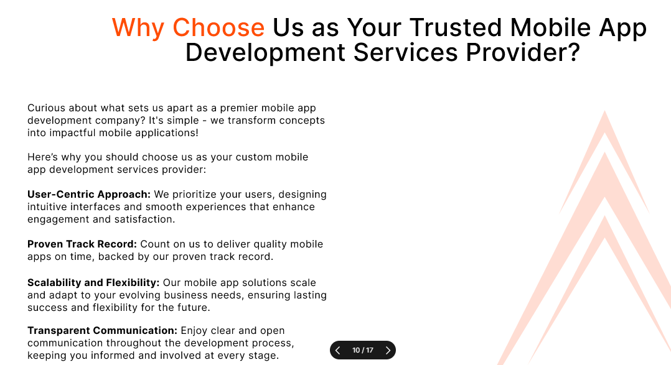

**Our Mission - Empowering Your Journey with Innovation & Integrity**

At our core, our mission is to empower businesses with transformative digital solutions that drive growth and innovation. We are dedicated to leveraging our expertise and creativity to craft bespoke software that meets each client's unique needs and challenges.

Our commitment to excellence guides every aspect of our work, from initial concept to final delivery. We prioritize transparency, communication, and collaboration to ensure that our clients are always informed and involved throughout the software development process. By fostering strong partnerships built on trust and reliability, we aim to become the go-to digital partner for businesses seeking to thrive in today’s competitive landscape.

Our mission is not just to meet expectations, but to exceed them, delivering tangible results and measurable impact for our clients. With a focus on continuous improvement and adaptation to emerging technologies, we strive to stay at the forefront of the industry, driving innovation and pushing boundaries to help our clients succeed in their digital endeavors.

Top of Form

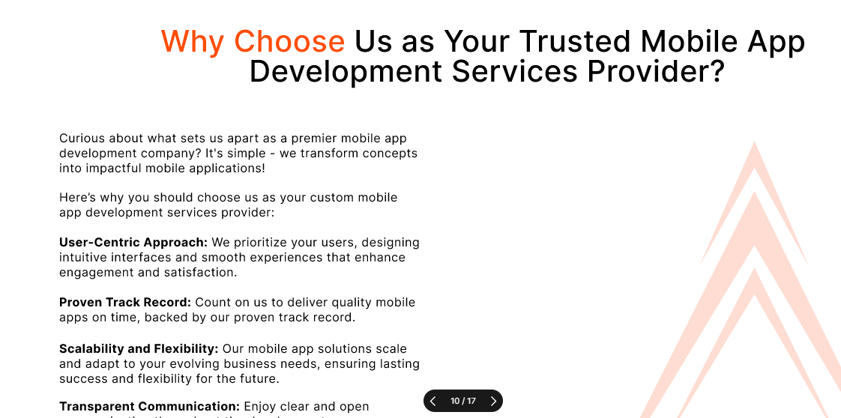

**The Praetors – Custom Software Application Development Company in the USA**

With over two decades of experience in software outsourcing, The Praetors emerges as a seasoned digital partner for businesses looking for performance-driven software integration services.

Our extensive expertise encompasses an in-depth understanding of organizational culture, strategic utilization of a diverse global talent pool, effective cost management, growth-oriented approaches, and unwavering commitment to transparency.

Leveraging globally dispersed teams and on-shore facilities strategically located in the USA, UK, and Asia, we facilitate global enterprises in their journey of innovation and business transformation.

|  |  |
| --- | --- |
| **Quality Products** | We’re all about delivering top-notch stuff, making sure it's spot-on and totally reliable, so you're always happy with what you get. |
| **Robust Development** | When we build custom software, we make sure it's super tough and can handle whatever you need it to do. That's how we roll! |
| **Latest Tech Stack** | We’re all about using the coolest, newest tech to make awesome custom software that's ahead of the game and helps your business grow. |
| **Complete Transparency** | We’re open books here, keeping you in the loop every step of the way so you know exactly what's happening with your custom software development project. No secrets here! |

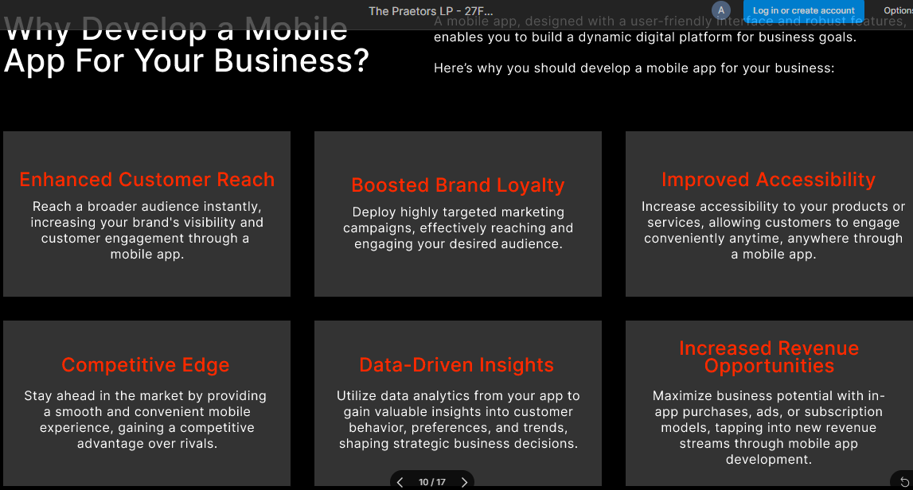

**Why Opt For Custom Software Development For Your Business?**

Custom software development is tailored specifically to your business needs, offering unique solutions that off-the-shelf software can't provide. It enhances efficiency, streamlines processes, and boosts productivity, giving you a competitive edge in the market.

With custom software, you have full control over features and functionalities, ensuring it aligns perfectly with your business goals and objectives.

|  |  |  |
| --- | --- | --- |
| **Customized Solutions**  Tailored to your specific business needs, custom software development offers solutions designed exclusively for your operations, ensuring optimal functionality and efficiency. | **Scalability**  With custom software development, your system can easily adapt and grow alongside your business, accommodating increased workload and expanding requirements without compromising performance. | **Enhanced Security**  Custom software provides robust security measures tailored to your business, offering protection against potential cyber threats and ensuring the safety of your sensitive data. |
| **Integration Capabilities**  Custom software seamlessly integrates with existing systems and applications within your organization, facilitating smooth workflow and eliminating data silos. | **Cost-effectiveness**  While initial development costs may be higher, custom software development eliminates recurring licensing fees associated with off-the-shelf solutions, resulting in long-term cost savings for your business. | **Competitive Advantage**  By leveraging custom software tailored to your unique business processes, you gain a competitive edge in the market, allowing you to innovate, differentiate, and stay ahead of the competition. |

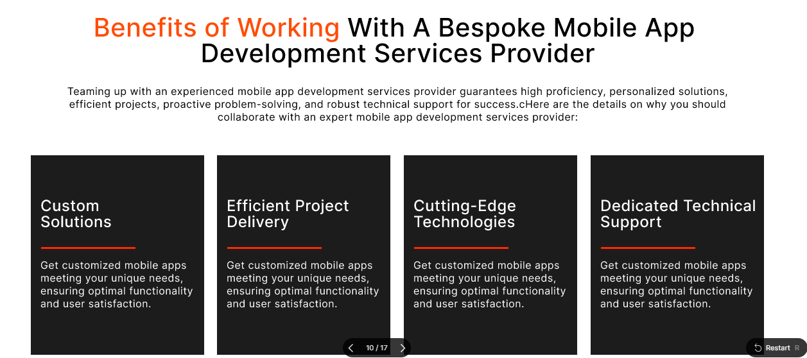

**Benefits of Working With A Professional & Reliable Custom Software Development Company**

Partnering with The Praetors offers numerous benefits. From expert guidance and streamlined communication to high-quality solutions and timely delivery, you can trust in our expertise to enhance your business operations and drive growth in today’s competitive market landscape.

|  |  |  |  |
| --- | --- | --- | --- |
| **Future-Ready Products**  We're all about staying ahead of the game, crafting innovative solutions that'll tackle tomorrow's challenges head-on. | **Dedicated Team**  Count on us to bring your ideas to life! Our custom software developers are dedicated, skilled, and ready to make your vision a reality. | **Customer Experience**  We’re here to make your experience seamless and personalized, tailored just for you and your success. | **Satisfaction Guarantee**  Your satisfaction is our top priority. We're committed to making sure you're thrilled with the results. |

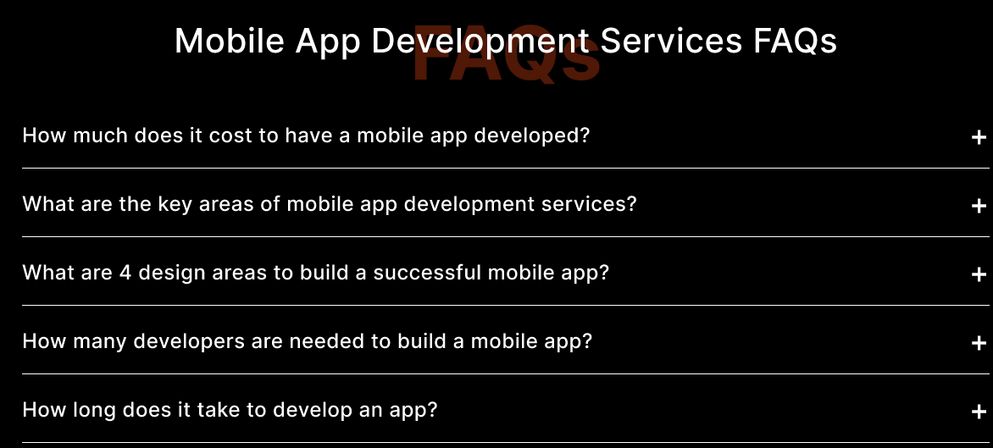

**Custom Software Development Services FAQs**

**1. How long does it take to develop custom software?**

The custom software development timeline varies based on project complexity, features, and client requirements. Generally, it can range from a few weeks to several months.

**2. What factors influence the cost of custom software development?**

Several factors affect the cost, including project scope, complexity, required features, development time, and the hourly rate of developers. Contact us to discuss your project details for an accurate estimate.

**3. Can custom software integrate with existing systems?**

Yes, custom software can seamlessly integrate with existing systems and applications within your organization, ensuring smooth data flow and workflow efficiency.

**4. How do you ensure data security and privacy in custom software?**

We implement robust security measures such as encryption, access controls, and regular security updates to safeguard sensitive data from unauthorized access or breaches.

**5. What ongoing support and maintenance options are available for custom software?**

We offer ongoing support and maintenance services post-launch, including bug fixes, updates, feature enhancements, and technical support to address any issues that may arise.

**6. How can I ensure the custom software meets my specific business needs and requirements?**

Thorough requirements gathering and analysis are conducted at the project’s onset. Close collaboration between our team and stakeholders ensures understanding and addressing all requirements, aligning the software perfectly with your business goals. Top of Form

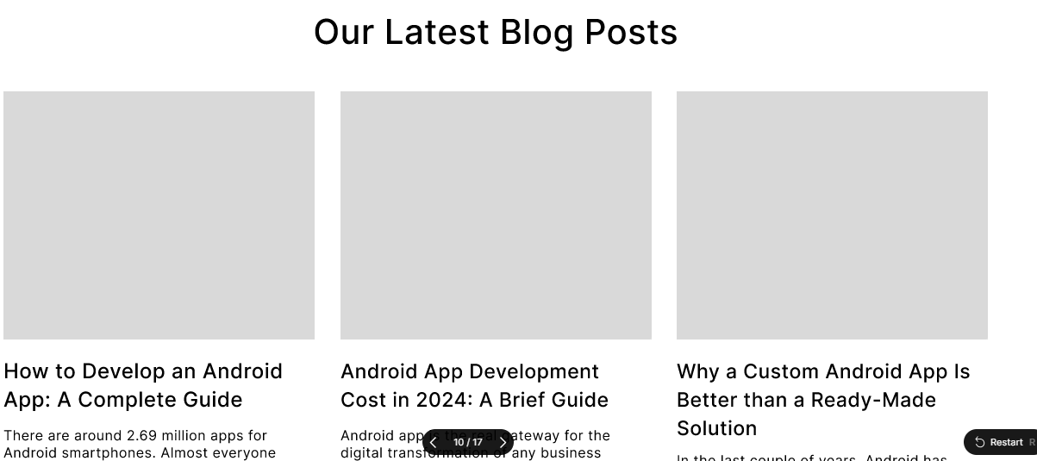

**READ OUR LATEST BLOG**

**[BLOGS HERE]**

# ANDROID APP DEVELOPMENT

**META TITLE**: Android App Development Services | The Praetors

**META DESCRIPTION**: Strengthen your business with our custom Android application development services. Expert development, intuitive design, and seamless user experiences. Contact us now!

**URL**:



**ANDROID APP DEVELOPMENT SERVICES**

In today's fast-paced digital landscape, Android apps play a pivotal role in connecting businesses with their target audience. The Praetors is a professional Android application development agency in the USA that excels in crafting bespoke mobile apps that cater to our clients' unique needs and aspirations. Our comprehensive Android app development services are tailored to leverage the full potential of the Android platform and deliver exceptional user experiences.



**Partner with Custom Android App Development Company for Robust, Performance-Driven Apps!**

We understand that each business has its own set of objectives and challenges. That's why we take a personalized approach to Android app development, starting with a thorough analysis of our clients' requirements and goals.

Our team works closely with clients to conceptualize, design, and develop custom Android applications that resonate with their brand identity and meet the demands of their target market.



**Seamlessly Connect with Your Audience Through Our Android App Development Services**

Backed by a team of seasoned Android app developers, we bring expertise and creativity to every project we undertake. From crafting clean and efficient code to implementing innovative features, our developers ensure that each app we deliver is of the highest quality.

With a focus on usability, performance, and security, we strive to exceed our clients' expectations and deliver solutions that make an impact.

|  |  |
| --- | --- |
| **Cross-Platform Compatibility** | Ensure seamless performance across various platforms, including iOS and Android, to reach a broader audience base. Expand your app's accessibility and maximize user engagement with consistent experiences on all devices. |
| **Customizable User Interface** | Tailor your app's design and layout to reflect your brand identity and resonate with your target audience. From color schemes to navigation menus, offer a personalized user experience that fosters brand recognition and user satisfaction. |
| **Robust Security Measures** | Implement advanced security protocols and encryption techniques to safeguard user data and protect against cyber threats. Prioritize user privacy and build trust by ensuring that your app adheres to industry standards for data protection and secure transactions. |



**Innovative Android App Development, Driven by Dynamic Tech Stacks**

We offer custom Android apps powered by state-of-the-art technology.



**Our Andoird App Development Process**

Our proficient workflow stands as the cornerstone of our achievements as a leading custom Android app development company. With flawless oversight at every stage, we harness premier resources to engineer resilient Android applications. Our adept team of developers upholds industry-standard principles throughout the development cycle, ensuring excellence in execution.

|  |  |
| --- | --- |
| **Discovery** | We begin by understanding your needs and goals and gathering essential information to lay the foundation for our collaboration. |
| **Planning** | With a clear understanding, we develop a detailed plan outlining the scope, timeline, and resources required for the project. |
| **Design** | Our team creates intuitive, user-friendly designs, ensuring the app aligns seamlessly with your vision and objectives. |
| **Development** | Our skilled Android app developers bring the designs to life, meticulously coding and building the app according to the outlined specifications. |
| **Testing** | Rigorous testing procedures are conducted to identify and resolve any issues, ensuring the app meets high standards of quality and functionality. |
| **Launch** | Once thoroughly tested and approved, we deploy the application, providing comprehensive support and guidance to ensure a smooth transition and optimal performance. |



|  |  |  |
| --- | --- | --- |
| **2+**  **Decades of Experience** | **137K+**  **Clients Globally** | **350K+**  **Digital Products Delivered** |



**Explore Our Game-Changing Android App Development Services**

We specialize in developing cutting-edge Android applications tailored to enhance your business's digital presence. Our dedicated Android app developers ensure a seamless user experience and integrate innovative features to meet your specific requirements.

Discover our range of bespoke Android app development solutions designed to drive your business forward. Top of Form

|  |  |
| --- | --- |
| **Android App Development Consultation**  We bridge the gap between your ideas and Android user expectations. Our consultants tailor strategies to align your business with Android users' needs, helping you make informed choices to stand out in the app store. | **Android UI/UX Design**  Our design team creates exclusive experiences within the Android ecosystem. Trust us to craft seamless user experiences that resonate across all Android devices, ensuring your app stands out and effectively engages users. |
| **Android Application Development**  Leverage our expertise to build robust and scalable solutions using the latest stack. Our custom Android app services cater to various industries, ensuring your app represents your unique identity amidst competition in the app store. | **Android Software Testing**  We employ a mix of automated and manual testing to ensure your app meets quality standards. Our testing process maintains a secure and performance-centric approach, delivering a glitch-free experience for your Android mobile application. |



**Our Android App Developers Offer Industry-Specific App Development Services**

When you partner with The Praetors for Android app development, you're choosing a hassle-free journey to digitize your business. Our comprehensive approach ensures a top-notch experience, taking care of all the details.

Explore our expertise across various industries and discover tailored solutions that set your business apart in the digital landscape.



**Our Mission - Empowering Your Journey with Innovation & Integrity**

At our core, our mission is to empower businesses with transformative digital solutions that drive growth and innovation. We are dedicated to leveraging our expertise and creativity to craft bespoke digital products that meet the unique needs and challenges of each client.

Our commitment to excellence guides every aspect of our work, from initial concept to final delivery. We prioritize transparency, communication, and collaboration to ensure that our clients are always informed and involved throughout the Android app development process. By fostering strong partnerships built on trust and reliability, we aim to become the go-to digital partner for businesses seeking to thrive in today’s competitive landscape.

Our mission is not just to meet expectations, but to exceed them, delivering tangible results and measurable impact for our clients. With a focus on continuous improvement and adaptation to emerging technologies, we strive to stay at the forefront of the industry, driving innovation and pushing boundaries to help our clients succeed in their digital endeavors.



**Unlock the Power of Android App Development with The Praetors**

When you partner with The Praetors, a leading and reliable Android app development company in the US, you’re selecting a seasoned team of experts poised to transform your concepts into successful applications.

We commence by attentively listening to your requirements, ensuring a thorough comprehension of your aspirations.

Subsequently, our adept Android app developers utilize their technical prowess to craft applications that not only function seamlessly but also delight end users.

Our commitment extends beyond development; we pledge ongoing support and updates to maintain the excellence of your application, allowing you to concentrate on business growth and customer satisfaction.

|  |  |
| --- | --- |
| **Quality-First Approach** | We’re all about delivering top-notch stuff, making sure it's spot-on and totally reliable, so you're always happy with what you get. |
| **Robust Development** | When we build a custom Android app, we make sure it’s brilliant in every way and functions fully, handling whatever you need it to do. That’s how we roll! |
| **Latest Tech Stack** | We’re all about using the coolest, newest tech to make an awesome custom app that’s ahead of the game and helps your business grow. |
| **Complete Transparency** | We’re open books here, keeping you in the loop every step of the way so you know exactly what's happening with your custom Android app development project. No secrets here! |



**Why Opt For Custom Android App Development For Your Business?**

With a dominant market share of 70.5 percent in the third quarter of 2023, Android solidified its position as the world's leading mobile operating system. This underscores the strategic importance of having an Android app for your business.

An Android app not only expands your customer base but also elevates customer engagement, making it a vital asset for your business growth.

|  |  |  |
| --- | --- | --- |
| **Unlock a Global Audience**  Android apps broaden your market horizon, connecting you with a diverse global audience and extending your reach beyond borders. | **Engage Directly with Customers**  Apps offer a direct and interactive platform for fostering deeper connections with customers, nurturing stronger relationships, and enhancing brand loyalty. | **Boost Visibility**  With your app readily accessible on users' devices, your business gains increased visibility, ensuring easy access and visibility in the competitive digital landscape. |
| **Fostering Customer Loyalty**  The convenience and personalized experience provided by your app fosters strong customer loyalty, driving repeat business and advocacy. | **Precision Targeting**  Leverage apps to execute highly targeted marketing campaigns, delivering tailored messages to the right audience at the right time. | **Enhanced User Experience**  Deliver seamless and user-friendly interactions through your app, enhancing your brand's reputation and ensuring a positive user experience. |



**Perks of Working with an Expert Android App Development Company**

Partnering with The Praetors ensures a seamless journey towards digital transformation through Android app development. We carefully handle every aspect to deliver a superior experience, allowing you to effortlessly focus on your business growth.

|  |  |  |  |
| --- | --- | --- | --- |
| **Future-Ready Products**  We're all about staying ahead of the game, crafting innovative solutions that'll tackle tomorrow’s challenges head-on. | **Dedicated Team**  Count on us to bring your ideas to life! Our Android app developers are dedicated, skilled, and ready to make your vision a reality. | **Customer Experience**  We’re here to make your experience seamless and personalized, tailored just for you and your success. | **Satisfaction Guarantee**  Your satisfaction is our top priority. We’re committed to making sure you’re thrilled with the results. |



**Android App Development FAQs**

**How long does it take to develop an Android app?**

The time required to develop an Android app varies based on its complexity, features, and customization needs. Typically, it can take anywhere from a few weeks to several months.

**What factors influence the cost of Android app development?**

Several factors impact the cost, including the app’s complexity, features, design, development hours, testing, maintenance, and post-launch support requirements.

**Do I need to have technical knowledge to develop an Android app?**

While technical knowledge can be helpful, it’s not mandatory. Working with a professional Android app development company allows you to bring your ideas to life without the need for extensive technical expertise.

**How do you ensure the security of Android apps?**

We prioritize security throughout the development process, implementing best practices for data encryption, secure authentication, and robust authorization mechanisms to safeguard user data and prevent unauthorized access.

**Can you assist with publishing the app on the Google Play Store?**

Yes, we provide comprehensive support, including assistance with app store submission, compliance with Google Play Store guidelines, and optimization of app listings for maximum visibility and reach.

**Do you offer ongoing maintenance and support for Android apps?**

Absolutely. We offer maintenance and support services post-launch to ensure your app remains up-to-date, secure, and optimized for performance. Our team is available to address any issues, implement updates, and provide technical assistance as needed.



**READ OUR LATEST BLOG**

**[BLOGS HERE]**

# IOS APP DEVELOPMENT

**META TITLE**: iOS App Development Services | The Praetors

**META DESCRIPTION**: Unlock the potential of iOS with custom app development. Expertly crafted iOS apps for enhanced user experiences and business growth. Explore our iOS app development solutions today!

**URL**:



**Top iOS App Development Company**

The Praetors stands out as a premier iPhone app development partner for ambitious entrepreneurs and enterprise clients alike. Our focus on user-centric design and innovation ensures that each custom iOS app we create delivers exceptional value, doubling our clients’ return on investment.



**Partner with Professional iOS App Development Company for Robust, Performance-Driven Apps!**

With over 2+ decades of dedicated experience in iOS app development, our team has honed the art of transforming your ideas into remarkable applications. We specialize in crafting iOS apps that captivate users with their seamless functionality and stunning design. Utilizing agile methodologies and technical prowess, we ensure your app's swift and successful delivery.

Entrust us with navigating the intricacies of iPhone app development to strengthen your brand’s digital presence and provide users with an unparalleled mobile experience that keeps them engaged and coming back for more. Let us help you unlock the full potential of your iOS app idea and confidently achieve your business objectives.



**Cutting-edge iOS App Development Services Designed for Success and Growth!**

Experience a transformative journey with our iPhone app development services, designed to steer your business towards new heights of success in the digital landscape. We specialize in crafting mobile applications that not only penetrate the market effectively but also deliver substantial value to your audience.

Our mission is to provide flawless iOS app development solutions that exceed our clients’ expectations and drive success. Let us be your partner in achieving excellence in the world of mobile technology.

|  |  |
| --- | --- |
| **Cross-Platform Compatibility** | Ensure seamless performance across various platforms, including iOS and Android, to reach a broader audience base. Expand your app’s accessibility and maximize user engagement with consistent experiences on all devices. |
| **Customizable User Interface** | Tailor your app’s design and layout to reflect your brand identity and resonate with your target audience. From color schemes to navigation menus, offer a personalized user experience that fosters brand recognition and user satisfaction. |
| **Robust Security Measures** | Implement advanced security protocols and encryption techniques to safeguard user data and protect against cyber threats. Prioritize user privacy and build trust by ensuring that your app adheres to industry standards for data protection and secure transactions. |



**Innovative iOS App Development, Driven by Dynamic Tech Stacks**

We offer custom-made iPhone apps powered by state-of-the-art technology.



**Our Efficient iPhone App Development Process**

Our efficient workflow is the foundation of our success as a top iOS app development company. We manage each phase carefully, using high-quality resources to create robust iPhone apps. Following industry standards closely, our experienced iOS team ensures smooth development cycles and delivers excellence at every step. Trust us to bring your iOS app ideas to fruition with expertise and dedication.

|  |  |
| --- | --- |
| **Discovery** | We begin by understanding your needs and goals and gathering essential information to lay the foundation for our collaboration. |
| **Planning** | With a clear understanding, we develop a detailed plan outlining the scope, timeline, and resources required for the project. |
| **Design** | Our team creates intuitive, user-friendly designs, ensuring the app aligns seamlessly with your vision and objectives. |
| **Development** | Our skilled iOS app developers bring the designs to life, fla coding and building the app according to the outlined specifications. |
| **Testing** | Rigorous testing procedures are conducted to identify and resolve any issues, ensuring the app meets high standards of quality and functionality. |
| **Launch** | Once thoroughly tested and approved, we deploy the application, providing comprehensive support and guidance to ensure a smooth transition and optimal performance. |



|  |  |  |
| --- | --- | --- |
| **2+**  **Decades of Experience** | **137K+**  **Clients Globally** | **350K+**  **Digital Products Delivered** |



**Explore Our Game-Changing iOS App Development Services**

Discover the transformative iPhone app development solutions offered by The Praetors. Our services are designed to revolutionize user experiences and drive business growth. With our game-changing approach, we deliver innovative iOS applications that set new industry standards.

Partner with us to unleash the full potential of your app ideas and take your business to the next level in the digital landscape.

|  |  |
| --- | --- |
| **iOS App Development Consultation**  As a prominent iPhone app development company, The Praetors focuses on understanding your iOS app's unique requirements. Through a detailed assessment, we offer insightful feedback supported by data, aiding in the creation of a comprehensive iOS solution for your brand. | **iOS App UI/UX Design**  Our skilled iPhone app developers prioritize delivering innovative and seamless user experiences. Leveraging their creativity, they design captivating iOS app interfaces that perfectly blend with your business and the Apple ecosystem. |
| **iPhone Application Development**  Our proficient team of strategists, architects, and iOS app designers amalgamate technology, features, and expertise to develop top-notch native iOS mobile apps. We ensure an optimized and flawless user experience for your app. | **iOS App Testing & QA**  We conduct thorough testing and validation to ensure the reliability and functionality of your business-critical iOS applications. Our rigorous testing procedures guarantee that your iOS projects are secure, highly usable, and tailored to your organization's specific requirements.  Top of Form |



**Industries We Serve with Our Performance-Driven iOS App Development**

The Praetors transforms businesses through groundbreaking app solutions, empowering them to maximize their capabilities. Specializing in cutting-edge iOS app development, we create tailored solutions for various industries, reshaping traditional approaches and delivering exceptional results.

Here are the sectors we cater to:



**Our Mission - Empowering Your Journey with Innovation & Integrity**

At our core, our mission is to empower businesses with transformative digital solutions that drive growth and innovation. We are dedicated to leveraging our expertise and creativity to craft bespoke digital products that meet the unique needs and challenges of each client.

Our commitment to excellence guides every aspect of our work, from initial concept to final delivery. We prioritize transparency, communication, and collaboration to ensure that our clients are always informed and involved throughout the iOS app development process. By fostering strong partnerships built on trust and reliability, we aim to become the go-to digital partner for businesses seeking to thrive in today’s competitive landscape.

Our mission is not just to meet expectations, but to exceed them, delivering tangible results and measurable impact for our clients. With a focus on continuous improvement and adaptation to emerging technologies, we strive to stay at the forefront of the industry, driving innovation and pushing boundaries to help our clients succeed in their digital endeavors.



**Choosing The Praetors As Your iPhone App Development Partner**

Partnering with The Praetors for your iOS app development needs offers several advantages. Firstly, we possess extensive knowledge of both traditional and emerging technologies, ensuring we employ the most suitable technology stack and agile methodologies for your project.

Secondly, we boast a team of elite iOS app developers and QA engineers dedicated to ensuring the performance and scalability of your digital assets.

Lastly, we prioritize meeting the evolving needs of your customers, crafting apps with highly functional features that deliver exceptional user experiences.

|  |  |
| --- | --- |
| **Quality-First Approach** | We’re all about delivering top-notch stuff, making sure it's spot-on and totally reliable, so you're always happy with what you get. |
| **Robust Development** | When we build a custom iOS app, we ensure it’s brilliant in all ways and functions fully, handling whatever you need. That’s how we roll! |
| **Latest Tech Stack** | We’re all about using the coolest, newest tech to make an awesome custom app that’s ahead of the game and helps your business grow. |
| **Complete Transparency** | We’re open books here, keeping you in the loop every step of the way so you know exactly what's happening with your custom iOS app development project. No secrets here! |



**Advantages iOS App Development Offers for Your Business Digitization**

With the Apple store dominating the market, accounting for over 62% of global revenue, now is the time to seize the opportunities it offers. iOS apps streamline operations, simplifying processes for both businesses and users. Discover the benefits of iOS app development to boost efficiency and convenience, driving your business towards success.

|  |  |  |
| --- | --- | --- |
| **Boosted Revenue Potential**  iOS app development can drive higher revenue, with iOS users more inclined to make in-app purchases, offering businesses lucrative opportunities. | **Enterprise-ready Features**  iOS offers robust enterprise features like Mobile Device Management (MDM), which streamlines device fleet management for businesses and enhances operational efficiency. | **Robust Security Measures**  iOS prioritizes stringent security, including encryption and theft protection, ensuring customer privacy and data security. |
| **Top-notch Quality Standards**  iOS apps undergo rigorous quality assessments for App Store approval, ensuring flawless performance and building user trust. | **Tech-Savvy Audience**  iOS users are inclined towards innovation, providing businesses with a platform to create cutting-edge apps and influence market dynamics. | **Seamless Integration with Apple Ecosystem**  Opting for iOS ensures seamless integration within the Apple ecosystem, fostering operational efficiency and synergy across your technology infrastructure. |



**Perks of Partnering with a Leading iPhone App Development Company**

When you collaborate with The Praetors, a top-rated iOS app development company, you unlock a pathway to accelerated business growth. Our innovative services offer a multitude of benefits that can maneuver your business forward, ensuring success in the competitive market landscape.

|  |  |  |  |
| --- | --- | --- | --- |
| **Future-Ready Products**  We’re all about staying ahead of the game, crafting innovative solutions that'll tackle tomorrow’s challenges head-on. | **Dedicated Team**  Count on us to bring your ideas to life! Our iOS app developers are dedicated, skilled, and ready to make your vision a reality. | **Customer Experience**  We’re here to make your experience seamless and personalized, tailored just for you and your success. | **Satisfaction Guarantee**  Your satisfaction is our top priority. We’re committed to making sure you’re thrilled with the results. |



**iOS App Development FAQs**

**How long does it take to develop an iOS app?**

The time frame depends on the complexity of the app. Typically, it takes anywhere from 4 to 9 months from concept to launch.

**What is the cost of iOS app development?**

The cost varies based on features, design complexity, and development time. We offer flexible pricing models tailored to your budget and project requirements.

**Do you provide post-launch support and maintenance?**

Yes, we offer comprehensive support and maintenance packages to ensure your app runs smoothly post-launch.

**Can you assist with App Store submission and approval?**

Yes, we guide you through the App Store submission process and ensure compliance with Apple’s guidelines for successful approval.

**Do you offer custom UI/UX design for iOS apps?**

Absolutely; our team of experienced designers creates bespoke UI/UX designs tailored to your brand and user preferences.

**What security measures do you implement in iOS app development?**

We prioritize security with encryption, data protection, secure authentication, and regular security updates to safeguard user data and privacy.



**READ OUR LATEST BLOG**

**[BLOGS HERE]**

# Flutter APP DEVELOPMENT

**META TITLE**: Best Flutter App Development Company | The Praetors

**META DESCRIPTION**: Partner with The Praetors, a professional flutter app development company that creates innovative cross-platform applications tailored to your business needs.

**URL**:



**Top Flutter App Development Company in USA**

Crafting robust web and mobile applications is our forte. As a dedicated Flutter app development agency, we prioritize excellence, innovation, and user delight in every project. Our mission is to deliver top-notch solutions that exceed expectations and propel your business forward.



**Partner with Professional Flutter App Development Company for Robust, Performance-Driven Apps!**

With a 2+ decades of app development expertise, we specialize in crafting innovative and feature-rich native mobile applications tailored for seamless user experiences on iOS devices. Leveraging the powerful Flutter Framework by Google, we accelerate the development process by swiftly creating MVPs for your app, targeting iOS, Android, and web users alike.

At The Praetors, we blend our deep expertise in development with cross-platform knowledge to engineer apps that boast superior features and a client-centric approach. Trust us to deliver solutions that not only meet but exceed your expectations, ensuring your app stands out in the competitive landscape.



**Is Flutter App Development Right For Your Business Needs? Let’s Find Out!**

Whether you're initiating a project from the ground up or seeking enhancements, rest assured, we deliver excellent Flutter app development solutions. Our expertise ensures a seamless journey, whether you're venturing into uncharted territory or upgrading existing applications. Discover the opportune moment to enlist our Flutter application development services, ensuring a smooth transition and optimized outcomes for your project.

|  |  |
| --- | --- |
| **Cross-Platform Compatibility** | Ensure seamless performance across various platforms, including iOS and Android, to reach a broader audience base. Expand your app’s accessibility and maximize user engagement with consistent experiences on all devices. |
| **Customizable User Interface** | Tailor your app’s design and layout to reflect your brand identity and resonate with your target audience. From color schemes to navigation menus, offer a personalized user experience that fosters brand recognition and user satisfaction. |
| **Robust Security Measures** | Implement advanced security protocols and encryption techniques to safeguard user data and protect against cyber threats. Prioritize user privacy and build trust by ensuring that your app adheres to industry standards for data protection and secure transactions. |



**Innovative Flutter App Development, Driven by Dynamic Tech Stacks**

We offer custom-made apps powered by state-of-the-art technology.



**Our Seamless Flutter App Development Process**

Our efficient workflow is the foundation of our success as a professional Flutter app development company. We manage each phase carefully, using high-quality resources to create robust mobile apps. Following industry standards closely, our experienced app development team ensures smooth cycles and delivers excellence at every step. Trust us to bring your app ideas to fruition with expertise and dedication.

|  |  |
| --- | --- |
| **Discovery** | We begin by understanding your needs and goals and gathering essential information to lay the foundation for our collaboration. |
| **Planning** | With a clear understanding, we develop a detailed plan outlining the scope, timeline, and resources required for the project. |
| **Design** | Our team creates intuitive, user-friendly designs, ensuring the app aligns seamlessly with your vision and objectives. |
| **Development** | Our skilled Flutter app development pros bring the designs to life, fla coding and building the app according to the outlined specifications. |
| **Testing** | Rigorous testing procedures are conducted to identify and resolve any issues, ensuring the app meets high standards of quality and functionality. |
| **Launch** | Once thoroughly tested and approved, we deploy the application, providing comprehensive support and guidance to ensure a smooth transition and optimal performance. |



|  |  |  |
| --- | --- | --- |
| **2+**  **Decades of Experience** | **137K+**  **Clients Globally** | **350K+**  **Digital Products Delivered** |



**Explore Our Comprehensive and Innovative Flutter App Development Services**

Experience groundbreaking Flutter app development solutions from The Praetors, designed to redefine user experiences and ensure business growth.

Our innovative approach sets industry benchmarks, delivering flutter applications that revolutionize and stand out in the digital arena.

Partner with us to unlock the full potential of your app concepts and elevate your business to unprecedented heights in the digital landscape.

|  |  |
| --- | --- |
| **Flutter App Consultation and Ideation**  With our dedicated Flutter developers, your ideas blossom into digital brilliance. During consultations, we attentively grasp your vision, providing tailored advice for building a robust Flutter app that resonates with your goals and objectives, ensuring a seamless development journey from concept to launch. | **Flutter UI/UX Design**  Enhance your app's interface with our expertise in Flutter UI/UX design. Collaborating closely, we create visually captivating and user-friendly interfaces, ensuring seamless digital experiences for your audience while aligning with your brand identity and user preferences. |
| **Flutter App Development**  Crafting versatile Flutter mobile apps, we establish a strong multi-platform presence. From inception to deployment, our Flutter developers guide you through the entire development process, delivering fully functional and feature-rich apps tailored to your requirements, enabling you to reach a broader audience and maximize user engagement. | **Flutter App Migration**  Simplify your app presence with our Flutter App Migration services. With specialized expertise in iOS and Flutter Android app migration, we ensure a smooth transition across platforms, optimizing performance and usability for your existing applications, allowing you to leverage the power of Flutter for enhanced functionality and improved user experiences across devices.Top of Form |



**Industries We Serve with Our Performance-Driven Flutter App Development**

At The Praetors, we lead the charge in business transformation through pioneering app solutions, enabling organizations to harness their full potential for success. With a specialized focus on cutting-edge Flutter app development, we flawlessly customize solutions to diverse industries, revolutionizing conventional practices and consistently delivering exceptional results.

Top of Form

Here are the sectors we cater to:



**Our Mission - Empowering Your Journey with Innovation & Integrity**

At our core, our mission is to empower businesses with transformative digital solutions that drive growth and innovation. We are dedicated to leveraging our expertise and creativity to craft bespoke digital products that meet the unique needs and challenges of each client.

Our commitment to excellence guides every aspect of our work, from initial concept to final delivery. We prioritize transparency, communication, and collaboration to ensure that our clients are always informed and involved throughout the Flutter app development process. By fostering strong partnerships built on trust and reliability, we aim to become the go-to digital partner for businesses seeking to thrive in today’s competitive landscape.

Our mission is not just to meet expectations, but to exceed them, delivering tangible results and measurable impact for our clients. With a focus on continuous improvement and adaptation to emerging technologies, we strive to stay at the forefront of the industry, driving innovation and pushing boundaries to help our clients succeed in their digital endeavors.



**Choosing The Praetors As Your Trusted Flutter App Development Company**

Partnering with The Praetors for your Flutter app development needs offers several advantages. Firstly, we possess extensive knowledge of both traditional and emerging technologies, ensuring we employ the most suitable technology stack and agile methodologies for your project.

Secondly, we boast a team of elite Flutter app development and QA engineers dedicated to ensuring the performance and scalability of your digital assets.

Lastly, we prioritize meeting the evolving needs of your customers, crafting apps with highly functional features that deliver exceptional user experiences.

|  |  |
| --- | --- |
| **Quality-First Approach** | We’re all about delivering top-notch stuff, making sure it's spot-on and totally reliable, so you're always happy with what you get. |
| **Robust Development** | When we build a custom iOS app, we ensure it’s brilliant in all ways and functions fully, handling whatever you need. That’s how we roll! |
| **Latest Tech Stack** | We’re all about using the coolest, newest tech to make an awesome custom app that’s ahead of the game and helps your business grow. |
| **Complete Transparency** | We’re open books here, keeping you in the loop every step of the way so you know exactly what's happening with your custom Flutter app development project. No secrets here! |



**Advantages Flutter App Development Offers for Your Business Digitization**

Discover the transformative potential of Flutter app development in digitizing your business. This innovative approach offers numerous benefits, streamlining operations, enhancing user experiences, and driving growth. Explore how leveraging Flutter technology can revolutionize your digital presence and propel your business forward in today's competitive landscape.

|  |  |  |
| --- | --- | --- |
| **Cross-Platform Efficiency**  Develop for Android and iOS simultaneously with Flutter's single codebase, minimizing time and costs. Achieve broad compatibility and efficient resource utilization for streamlined app deployment and management. | **Dynamic Interfaces**  Create captivating UIs with Flutter's versatile components, enhancing user engagement and navigation simplicity. Drive user satisfaction with visually appealing and intuitive interfaces optimized for diverse devices. | **Rapid Iterations**  Utilize Flutter's hot reload feature for real-time code updates, accelerating development cycles. Enable quick adjustments and iterations for swift progress, reducing time to market and enhancing project flexibility. |
| **Optimized Performance**  Benefit from near-native performance with Flutter's direct compilation to machine code. Ensure seamless user experiences with smooth operation and responsive interactions across multiple platforms and devices. | **Vibrant Community Support**  Access a vibrant open-source community for resources, plugins, and assistance. Leverage collective expertise and collaboration opportunities for continuous improvement and innovation in Flutter app development endeavors. | **Cost-Efficient Development**  Maximize cost-efficiency by targeting multiple platforms with Flutter. Reduce development and maintenance expenses while delivering high-quality, cross-platform app solutions tailored to your business needs. |



**Benefits of Partnering with The Praetors - A Leading Flutter App Development Company**

Engage with The Praetors, a premier Flutter application development company, to drive your business forward. Our innovative solutions offer a great deal of advantages, ensuring your success in today's competitive market. With our customized services, unlock growth opportunities and thrive in the ever-evolving landscape of business. Partner with us and accelerate your journey towards excellence.Top of Form

|  |  |  |  |
| --- | --- | --- | --- |
| **Future-Ready Products**  We’re all about staying ahead of the game, crafting innovative solutions that'll tackle tomorrow’s challenges head-on. | **Dedicated Team**  Count on us to bring your ideas to life! Our Flutter app development pros are dedicated, skilled, and ready to make your vision a reality. | **Customer Experience**  We’re here to make your experience seamless and personalized, tailored just for you and your success. | **Satisfaction Guarantee**  Your satisfaction is our top priority. We’re committed to making sure you’re thrilled with the results. |



**Flutter App Development FAQs**

**How does Flutter differ from other frameworks?**

Flutter uses Dart programming language and offers hot reload functionality, enabling fast development and a smooth user experience.

**Is Flutter suitable for my project?**

Yes, Flutter is ideal for various projects, including MVPs, enterprise applications, and complex UI designs.

**What are the benefits of Flutter app development?**

Flutter provides faster development, expressive UI, native performance, and cross-platform compatibility, reducing time-to-market and development costs.

**What is the Flutter app development process like?**

The process typically involves project discovery, UI/UX design, development, testing, deployment, and post-launch support, ensuring a seamless and efficient development journey.

**Does Flutter support native features?**

Yes, Flutter provides access to native features and APIs through platform channels, enabling developers to integrate device-specific functionalities seamlessly.

**Can Flutter apps be published on both Google Play Store and Apple App Store?**

Absolutely, Flutter allows developers to publish apps on both platforms using a single codebase, ensuring broad reach and accessibility.



**READ OUR LATEST BLOG**

**[BLOGS HERE]**

# React Native App Development Services

**META TITLE**: React Native App Development Services | The Praetors

**META DESCRIPTION**: Explore innovative React Native mobile application development services at The Praetors. Build cross-platform mobile apps efficiently with our expert team. Contact us today!

**URL**:



**No. 1 React Native App development Company in USA**

For top-tier React Native app development solutions, The Praetors is the perfect partner for you. As a leading React Native app development services providers in the US, we deliver world-class services tailored to meet your unique needs. With extensive experience and expertise in mobile app development, our team ensures excellence in utilizing React Native and other cutting-edge frameworks to bring your app ideas to life.

Top of Form



**Partner with Top-Rated React Native Mobile App Development Company for Seamless, Fully-Functional Apps!**

React Native simplifies native app development, offering advanced capabilities for handling multimedia data. Integrated with CSS or JavaScript, it boosts performance and provides semantic elements. Companies opt for React Native to streamline cross-platform app implementation, reducing costs and complexity.

With its platform-agnostic framework, React Native enables "write once, run anywhere" convenience. Our expertise in React Native app development ensures powerful hybrid mobile apps with enhanced performance, capabilities, and responsiveness for your next project.Top of Form



**When To Consider Our Robust React Native App Development Services**

Explore our robust React Native app development services when you're ready to strengthen your digital presence. Our expertise ensures seamless cross-platform solutions that cater to your unique business needs, empowering you to reach a broader audience and achieve your goals effectively.Top of Form

|  |  |
| --- | --- |
| **Cross-Platform Compatibility** | Our React Native app development ensures your app functions seamlessly on both iOS and Android platforms, utilizing a single codebase. This feature minimizes development time and costs while maximizing reach and user accessibility across different devices. |
| **Native Performance** | Leveraging React Native's ability to compile code directly to native components, we deliver apps with near-native performance. Users experience swift interactions and responsive interfaces, enhancing overall satisfaction and engagement with your application. |
| **Rapid Development** | With React Native's hot reload feature, our developers can make real-time changes to the app's codebase, enabling rapid iterations and updates. This agile development approach accelerates the development cycle, allowing for quicker time-to-market and increased flexibility in responding to user feedback. |



**Performance-Driven React Native App Development, Driven by Dynamic Tech Stacks**

We offer custom-made apps powered by state-of-the-art technology.



**Our Seamless React Native App Development Process**

Experience a streamlined React Native app development process for guaranteed efficiency and excellence. From conception to deployment, our team guides you through planning, design, development, and testing, ensuring top-notch results. Partner with us for a hassle-free journey from idea to reality, backed by industry expertise and unwavering commitment to quality.

Top of Form

|  |  |
| --- | --- |
| **Discovery** | We begin by understanding your needs and goals and gathering essential information to lay the foundation for our collaboration. |
| **Planning** | With a clear understanding, we develop a detailed plan outlining the scope, timeline, and resources required for the project. |
| **Design** | Our team creates intuitive, user-friendly designs, ensuring the app aligns seamlessly with your vision and objectives. |
| **Development** | Our skilled React Native app development pros bring the designs to life, fla coding and building the app according to the outlined specifications. |
| **Testing** | Rigorous testing procedures are conducted to identify and resolve any issues, ensuring the app meets high standards of quality and functionality. |
| **Launch** | Once thoroughly tested and approved, we deploy the application, providing comprehensive support and guidance to ensure a smooth transition and optimal performance. |



|  |  |  |
| --- | --- | --- |
| **2+**  **Decades of Experience** | **137K+**  **Clients Globally** | **350K+**  **Digital Products Delivered** |



**Our Results-Driven React Native App Development Approach**

Discover the efficiency of our results-oriented React Native app development solutions. With a focus on delivering measurable results, we power up our advanced methodologies and cutting-edge tools to create bespoke applications that align with your strategic objectives.

From focused planning to flawless execution, our team is dedicated to driving impactful outcomes for your business. Strengthen your digital presence with our professional React Native app development services.

Top of Form

|  |  |
| --- | --- |
| **Full Development Cycle**  Partner with The Praetors, a leading React Native mobile app development company, for end-to-end development services. From initial design to testing and ongoing support, we cater to startups, enterprises, and entrepreneurs, elevating your business with bespoke solutions. | **React Native App Consultation**  Benefit from our team's extensive experience and insights with comprehensive React Native app consultation services. We provide in-depth analysis, strategic planning, and actionable recommendations to help you make informed decisions and achieve your app development objectives. |
| **MVP Development**  Unlock the full potential of your app idea with our expert React Native MVP development services. Our team specializes in crafting minimum viable products that perfectly align with your business goals and user expectations, ensuring rapid validation and market success. | **App Migration & Upgradation**  Whether you're upgrading to the latest React Native app version or migrating from another platform, we leverage cutting-edge technologies and industry best practices to ensure a smooth and cost-effective process while maximizing performance and user satisfaction.  Top of Form |



**Industries We Serve with Our Expert React Native App Development**

At The Praetors, we lead the charge in business transformation through pioneering app solutions, enabling organizations to harness their full potential for success. With a specialized focus on cutting-edge React Native app development, we flawlessly customize solutions to diverse industries, revolutionizing conventional practices and consistently delivering exceptional results.

Top of Form

Here are the sectors we cater to:



**Our Mission - Empowering Your Journey with Innovation & Integrity**

At our core, our mission is to empower businesses with transformative digital solutions that drive growth and innovation. We are dedicated to leveraging our expertise and creativity to craft bespoke digital products that meet the unique needs and challenges of each client.

Our commitment to excellence guides every aspect of our work, from initial concept to final delivery. We prioritize transparency, communication, and collaboration to ensure that our clients are always informed and involved throughout the React Native app development process. By fostering strong partnerships built on trust and reliability, we aim to become the go-to digital partner for businesses seeking to thrive in today’s competitive landscape.

Our mission is not just to meet expectations, but to exceed them, delivering tangible results and measurable impact for our clients. With a focus on continuous improvement and adaptation to emerging technologies, we strive to stay at the forefront of the industry, driving innovation and pushing boundaries to help our clients succeed in their digital endeavors.



**Choosing The Praetors As Your Trusted React Native App Development Company**

Partnering with The Praetors for your React Native app development needs offers several advantages. Firstly, we possess extensive knowledge of both traditional and emerging technologies, ensuring we employ the most suitable technology stack and agile methodologies for your project.

Secondly, we boast a team of elite React Native app development pros and QA engineers dedicated to ensuring the performance and scalability of your digital assets.

Lastly, we prioritize meeting the evolving needs of your customers, crafting apps with highly functional features that deliver exceptional user experiences.

|  |  |
| --- | --- |
| **Quality-First Approach** | We’re all about delivering top-notch stuff, making sure it's spot-on and totally reliable, so you're always happy with what you get. |
| **Robust Development** | When we build a custom React Native app, we ensure it’s brilliant in all ways and functions fully, handling whatever you need. That’s how we roll! |
| **Latest Tech Stack** | We’re all about using the coolest, newest tech to make an awesome custom app that’s ahead of the game and helps your business grow. |
| **Complete Transparency** | We’re open books here, keeping you in the loop every step of the way so you know exactly what's happening with your custom React Native app development project. No secrets here! |



**Perks of Our React Native App Development for Your Business Digitization**

Experience the transformative benefits of our React Native app development services for your business digitization journey. Our expert team harnesses the power of React Native to create high-performance, cross-platform apps that boost your brand visibility and drive growth. With streamlined development processes and innovative solutions, we deliver scalable and user-friendly apps tailored to meet your specific business needs and objectives.

Top of Form

|  |  |  |
| --- | --- | --- |
| **Cost-Efficiency**  Our React Native app development offers cost-effective solutions, leveraging a single codebase for both Android and iOS platforms, minimizing development time and expenses while ensuring high-quality results. | **Cross-Platform Compatibility**  With React Native, we deliver apps that seamlessly run on multiple platforms, reaching a broader audience and maximizing market reach for your business. | **Rapid Development**  Benefit from our accelerated development process enabled by React Native's hot reload feature, allowing real-time code changes and faster iterations to bring your app to market quickly. |
| **Native Performance**  Enjoy near-native performance with React Native apps, as they are compiled to native code, providing smooth and responsive user experiences across devices. | **Enhanced User Experience**  We prioritize user experience in our React Native app development, crafting intuitive interfaces and engaging features that captivate users and drive retention rates. | **Community Support**  As part of the vibrant React Native community, we have access to a wealth of resources, plugins, and support, ensuring continuous innovation and updates for your app's success. |



**The Praetors – Your Trusted Partner For Innovative React Native Mobile Application Development Services**

With a track record of excellence, we deliver innovative and feature-packed solutions for startups, SMEs, and large enterprises alike. Backed by a team of seasoned professionals, we guide you through every step of your digital transformation journey, from technology consulting to solution design, ensuring your business emerges as a leader in the competitive market landscape. Partner with us for cost-effective, cutting-edge mobile app development solutions that take your enterprise to new heights of success.

|  |  |  |  |
| --- | --- | --- | --- |
| **Future-Ready Products**  We’re all about staying ahead of the game, crafting innovative solutions that'll tackle tomorrow’s challenges head-on. | **Dedicated Team**  Count on us to bring your ideas to life! Our React Native app pros are dedicated, skilled, and ready to make your vision a reality. | **Customer Experience**  We’re here to make your experience seamless and personalized, tailored just for you and your success. | **Satisfaction Guarantee**  Your satisfaction is our top priority. We’re committed to making sure you’re thrilled with the results. |



**React Native Mobile App Development FAQs**

**What is React Native and why should I choose it for my mobile app?**

React Native is a framework developed by Facebook for building mobile applications using JavaScript and React. It allows for the creation of cross-platform apps, meaning the same codebase can be used for both iOS and Android, saving time and resources.

**Can React Native apps be published on both iOS and Android platforms?**

Yes, React Native apps can be published on both iOS and Android platforms. React Native uses a single codebase, allowing developers to write once and deploy on multiple platforms.

**How long does it take to develop a React Native mobile app?**

The time it takes to develop a React Native mobile app can vary depending on the complexity of the project, features required, and the development team's experience. Typically, development timelines can range from a few weeks to several months.

**What are the key advantages of using React Native for app development?**

Some key advantages of using React Native include faster development time, cost-effectiveness, a large developer community, and the ability to create cross-platform apps with a single codebase.

**Do I need separate development teams for iOS and Android with React Native?**

No, one of the main advantages of React Native is that it allows for the development of cross-platform apps with a single codebase. This means you can use the same development team to build apps for both iOS and Android platforms.

**How does The Praetors ensure the security of React Native apps during development?**

At The Praetors, we prioritize the security of our clients' apps. We follow industry best practices for secure coding, conduct regular security audits, and implement measures such as data encryption and secure authentication to ensure the security of React Native apps during development.



**READ OUR LATEST BLOG**

**[BLOGS HERE]**

# GAME APP DEVELOPMENT

**META TITLE**: Mobile Game Development Company USA | The Praetors

**META DESCRIPTION**: Partner with The Praetors, a professional mobile game development company to boost your gaming experience. Transform your game ideas into reality with our expert team.

**URL**:



**Pioneering Mobile Game Development Company**

The Praetors, a premier mobile game development company, specializes in creating captivating 2D and 3D games for both iOS and Android platforms. With a focus on stunning graphics, fluid gameplay, and compelling storylines, our team delivers immersive gaming experiences that captivate players worldwide. Explore the limitless possibilities of mobile gaming with The Praetors today!

Top of Form



**Partner with Top Mobile Game Developers for Gaming Innovation!**

At The Praetors, our elite team of mobile game developers pairs cutting-edge tools and engines such as Unity, Unreal Engine, and Lumberyard to develop incomparable gaming experiences. With a proven track record in game app development, we've achieved remarkable success in delivering captivating games that push the boundaries of innovation. From concept to execution, we prioritize excellence and creativity, ensuring that each game we develop stands out in the competitive market.

Partner with The Praetors to bring your mobile game vision to life and make an impact in the gaming industry.

Top of Form



**Is Game App Development the Ideal Choice for Your Business? Let's Explore!**

Our mobile game development services cater to a wide spectrum of businesses, from startups to large enterprises, ensuring a tailored approach that meets your unique requirements. With our efficient development process, we commit to delivering your product within a timeframe of 4 to 6 months, ensuring timely deployment and impeccable execution.

|  |  |
| --- | --- |
| **Customizable Game Themes** | Customize your game to match your brand or target audience with customizable themes. From sleek and modern designs to whimsical and colorful aesthetics, our game app development services offer flexibility to align with your business identity and appeal to your desired demographic. |
| **In-App Purchase Integration** | Monetize your game app with seamless in-app purchase integration. Unlock revenue streams through various purchase options such as virtual goods, power-ups, or exclusive content, providing players with valuable incentives while driving profitability for your business. |
| **Analytics and Performance Tracking** | Gain insights into user behavior and performance metrics with robust analytics tools. Track player engagement, retention rates, and in-game transactions to make data-driven decisions and optimize your game for maximum user satisfaction and revenue generation.  Top of Form |



**Innovative Game App Development, Driven by Dynamic Tech Stacks**

We offer custom-made game apps powered by state-of-the-art technology.



**Our Seamless Game App Development Process**

Our efficient workflow is the foundation of our success as a professional game app development company. We manage each phase carefully, using high-quality resources to create robust digital products. Following industry standards closely, our experienced development team ensures smooth cycles and delivers excellence at every step. Trust us to bring your unique ideas to fruition with expertise and dedication.

|  |  |
| --- | --- |
| **Discovery** | We begin by understanding your needs and goals and gathering essential information to lay the foundation for our collaboration. |
| **Planning** | With a clear understanding, we develop a detailed plan outlining the scope, timeline, and resources required for the project. |
| **Design** | Our team creates intuitive, user-friendly designs, ensuring the app aligns seamlessly with your vision and objectives. |
| **Development** | Our top mobile game developers bring the designs to life, fla coding and building the app according to the outlined specifications. |
| **Testing** | Rigorous testing procedures are conducted to identify and resolve any issues, ensuring the app meets high standards of quality and functionality. |
| **Launch** | Once thoroughly tested and approved, we deploy the application, providing comprehensive support and guidance to ensure a smooth transition and optimal performance. |



|  |  |  |
| --- | --- | --- |
| **2+**  **Decades of Experience** | **137K+**  **Clients Globally** | **350K+**  **Digital Products Delivered** |



**Level Up Your Business with Our Next-Gen Mobile Game Development Services**

Ready to take your business to the next level? Our mobile game development services are here to make it happen. We create games that grab attention, keep players hooked, and drive results.

Whether you're a startup or an established brand, we've got the expertise to bring your ideas to life.

Let's collaborate and turn your gaming vision into a reality that players will love.

|  |  |
| --- | --- |
| **Android Game Development**  The Praetors stands out as a preferred choice among the best mobile game development companies, focusing on delivering exceptional Android game development services. We breathe life into your gaming concepts, customizing them to seamlessly integrate with the Android ecosystem. Our dedicated team, well-versed in the technical complexities of Android, guarantees a fluid and captivating user experience. | **iPhone App Development**  As a leading game app development company, The Praetors employs state-of-the-art technology and technical expertise to transform your gaming concepts into reality on iOS devices. Our iOS app development services provide smooth and engaging user experiences, positioning us as a frontrunner in iOS game development. |
| **Web Game Development**  The Praetors stands at the forefront of gaming enterprises, featuring a team that merges technical proficiency with creative ingenuity to produce compelling games accessible directly through your web browser. Utilizing cutting-edge technologies, we guarantee a seamless and immersive gaming encounter, pushing the limits of what web-based games can accomplish. | **AR/VR Game Development**  Our skilled team utilizes advanced technologies to craft enthralling and realistic gaming experiences, pushing the limits of what can be achieved. Emphasizing seamless interactivity and immersive storytelling, TekRevol turns your gaming concepts into virtual realities that captivate audiences. Hire us to use our AR/VR game development services to build multiplayer virtual environment games like Pokemon Go.Top of Form |



**Expanding Game App Development Horizons for Various Sectors**

Our mobile game development services transcend various sectors, bringing exciting gaming experiences to diverse audiences. From entertainment and education to healthcare and beyond, we leverage cutting-edge technology to create engaging games tailored to meet the unique needs of each sector. Partner with us to explore new horizons in game app development.

Top of Form

Here are the sectors we cater to:



**Our Mission - Empowering Your Journey with Innovation & Integrity**

At our core, our mission is to empower businesses with transformative digital solutions that drive growth and innovation. We are dedicated to leveraging our expertise and creativity to craft bespoke digital products that meet the unique needs and challenges of each client.

Our commitment to excellence guides every aspect of our work, from initial concept to final delivery. We prioritize transparency, communication, and collaboration to ensure that our clients are always informed and involved throughout the Flutter app development process. By fostering strong partnerships built on trust and reliability, we aim to become the go-to digital partner for businesses seeking to thrive in today’s competitive landscape.

Our mission is not just to meet expectations, but to exceed them, delivering tangible results and measurable impact for our clients. With a focus on continuous improvement and adaptation to emerging technologies, we strive to stay at the forefront of the industry, driving innovation and pushing boundaries to help our clients succeed in their digital endeavors.



**Choosing The Praetors As Your Trusted Mobile Game Development Company**

Partnering with The Praetors for your game app development needs offers several advantages. Firstly, we possess extensive knowledge of both traditional and emerging technologies, ensuring we employ the most suitable technology stack and agile methodologies for your project.

Secondly, we boast a team of elite mobile game developers and QA engineers dedicated to ensuring the performance and scalability of your digital assets.

Lastly, we prioritize meeting the evolving needs of your customers, crafting apps with highly functional features that deliver exceptional user experiences.

|  |  |
| --- | --- |
| **Quality-First Approach** | We’re all about delivering top-notch stuff, making sure it's spot-on and totally reliable, so you're always happy with what you get. |
| **Robust Development** | When we build a custom game app, we ensure it’s brilliant in all ways and functions fully, handling whatever you need. That’s how we roll! |
| **Latest Tech Stack** | We’re all about using the coolest, newest tech to make an awesome digital product that’s ahead of the game and helps your business grow. |
| **Complete Transparency** | We’re open books here, keeping you in the loop every step of the way so you know exactly what's happening with your game app development project. No secrets here! |



**Create Experiences that Players Love, Businesses Thrive on!**

Craft engaging games that players love while boosting business success. Our expert team creates fascinating experiences that captivate audiences and drive tangible results. With a focus on innovation and fineness in game app development, we turn gaming ideas into reality, ensuring both player enjoyment and business growth.

Top of Form

|  |  |  |
| --- | --- | --- |
| **Enhance Customer**  **Engagement**  A game app provides an entertaining and interactive platform to connect with your audience and keep them engaged with your brand. | **Foster Brand**  **Loyalty**  Delighting customers with enjoyable gaming experiences fosters a strong connection to your brand, encouraging repeat engagement and loyalty. | **Interactive Marketing**  **Solutions**  Engage customers in a unique way by offering immersive experiences through interactive game apps, creating memorable interactions and lasting impressions. |
| **Transform Learning into**  **Fun**  Utilize playful and interactive content in game apps to make learning enjoyable and engaging for users, turning educational experiences into enjoyable challenges. | **Drive Sales and**  **Revenue Growth**  Leverage game apps to boost sales through in-app purchases, advertisements, and premium features, creating new avenues for revenue generation and business growth. | **Enhance User**  **Experience**  Optimize user interaction and satisfaction with a seamless and user-friendly game app interface, elevating your brand's reputation and user experience. |



**Benefits of Partnering with The Praetors – Top Game App Development Company in USA**

Our expertise and dedication ensure top-notch solutions meeting your business’s unique needs. Experience our immaculate approach, streamlined processes, and commitment to perfection, lifting your business to the top in the competitive gaming industry. Choose The Praetors for unparalleled quality and success in game app development.

|  |  |  |  |
| --- | --- | --- | --- |
| **Future-Ready Products**  We’re all about staying ahead of the game, crafting innovative solutions that'll tackle tomorrow’s challenges head-on. | **Dedicated Team**  Count on us to bring your ideas to life! Our top mobile game developers are dedicated, skilled, and ready to make your vision a reality. | **Customer Experience**  We’re here to make your experience seamless and personalized, tailored just for you and your success. | **Satisfaction Guarantee**  Your satisfaction is our top priority. We’re committed to making sure you’re thrilled with the results. |



**Game App Development FAQs**

**How long does it take to develop a game app?**

The time frame varies depending on the complexity of the game, but typically, it can take anywhere from a few weeks to several months.

**What platforms can my game app be developed for?**

We specialize in developing game apps for iOS, Android, and web platforms to ensure maximum reach and accessibility for your audience.

**What are the costs associated with game app development?**

Costs vary based on factors such as app complexity, features, and platform. We offer tailored pricing packages to suit your budget and project requirements.

**Can you help with game concept and design?**

Yes, our team of experienced designers and developers can assist you in conceptualizing and designing your game app from scratch, ensuring it aligns with your vision and goals.

**Do you provide ongoing maintenance and support for game apps?**

Absolutely, we offer comprehensive maintenance and support services to ensure your game app remains up-to-date, secure, and optimized for performance even after launch.

**Is it possible to integrate monetization features into the game?**

Yes, we can integrate various monetization strategies such as in-app purchases, ads, subscriptions, and more to help you generate revenue from your game app.



**READ OUR LATEST BLOG**

**[BLOGS HERE]**

# Cross Platform App Development Company

**META TITLE**: Cross-Platform App Development Company | The Praetors

**META DESCRIPTION**: Explore our cross-platform app development services to reach a wider audience on multiple devices efficiently. Our experts ensure seamless integration across iOS, Android, & web platforms.

**URL**:



**Cross-Platform App Development Company**

Opting for cross-platform app development ensures superior user experiences in app development. At The Praetors, our adept team excels in crafting cross-platform mobile apps that seamlessly operate across various platforms. Utilizing cutting-edge tools, our developers deliver tailored solutions for cross-platform app development projects.

Top of Form

Top of Form



**The Praetors – Your One-Stop Shop for Cross-Platform Mobile App Development Services**

Experience seamless cross-platform app development solutions with The Praetors, your ultimate destination for comprehensive services. Our adept team specializes in creating versatile apps that function flawlessly across multiple platforms. From conceptualization to deployment, we ensure tailored solutions to meet your specific requirements, delivering exceptional user experiences.

Partner with us to unlock the full potential of cross-platform app development for your business.

Top of Form

Top of Form



**Is Game App Development the Ideal Choice for Your Business? Let's Explore!**

Our mobile game development services cater to a wide spectrum of businesses, from startups to large enterprises, ensuring a tailored approach that meets your unique requirements. With our efficient development process, we commit to delivering your product within a timeframe of 4 to 6 months, ensuring timely deployment and impeccable execution.

|  |  |
| --- | --- |
| **Customizable Game Themes** | Customize your game to match your brand or target audience with customizable themes. From sleek and modern designs to whimsical and colorful aesthetics, our game app development services offer flexibility to align with your business identity and appeal to your desired demographic. |
| **In-App Purchase Integration** | Monetize your game app with seamless in-app purchase integration. Unlock revenue streams through various purchase options such as virtual goods, power-ups, or exclusive content, providing players with valuable incentives while driving profitability for your business. |
| **Analytics and Performance Tracking** | Gain insights into user behavior and performance metrics with robust analytics tools. Track player engagement, retention rates, and in-game transactions to make data-driven decisions and optimize your game for maximum user satisfaction and revenue generation.  Top of Form |



**Innovative Game App Development, Driven by Dynamic Tech Stacks**

We offer custom-made game apps powered by state-of-the-art technology.



**Our Seamless Game App Development Process**

Our efficient workflow is the foundation of our success as a professional game app development company. We manage each phase carefully, using high-quality resources to create robust digital products. Following industry standards closely, our experienced development team ensures smooth cycles and delivers excellence at every step. Trust us to bring your unique ideas to fruition with expertise and dedication.

|  |  |
| --- | --- |
| **Discovery** | We begin by understanding your needs and goals and gathering essential information to lay the foundation for our collaboration. |
| **Planning** | With a clear understanding, we develop a detailed plan outlining the scope, timeline, and resources required for the project. |
| **Design** | Our team creates intuitive, user-friendly designs, ensuring the app aligns seamlessly with your vision and objectives. |
| **Development** | Our top mobile game developers bring the designs to life, fla coding and building the app according to the outlined specifications. |
| **Testing** | Rigorous testing procedures are conducted to identify and resolve any issues, ensuring the app meets high standards of quality and functionality. |
| **Launch** | Once thoroughly tested and approved, we deploy the application, providing comprehensive support and guidance to ensure a smooth transition and optimal performance. |



|  |  |  |
| --- | --- | --- |
| **2+**  **Decades of Experience** | **137K+**  **Clients Globally** | **350K+**  **Digital Products Delivered** |



**Level Up Your Business with Our Next-Gen Mobile Game Development Services**

Ready to take your business to the next level? Our mobile game development services are here to make it happen. We create games that grab attention, keep players hooked, and drive results.

Whether you're a startup or an established brand, we've got the expertise to bring your ideas to life.

Let's collaborate and turn your gaming vision into a reality that players will love.

|  |  |
| --- | --- |
| **Android Game Development**  The Praetors stands out as a preferred choice among the best mobile game development companies, focusing on delivering exceptional Android game development services. We breathe life into your gaming concepts, customizing them to seamlessly integrate with the Android ecosystem. Our dedicated team, well-versed in the technical complexities of Android, guarantees a fluid and captivating user experience. | **iPhone App Development**  As a leading game app development company, The Praetors employs state-of-the-art technology and technical expertise to transform your gaming concepts into reality on iOS devices. Our iOS app development services provide smooth and engaging user experiences, positioning us as a frontrunner in iOS game development. |
| **Web Game Development**  The Praetors stands at the forefront of gaming enterprises, featuring a team that merges technical proficiency with creative ingenuity to produce compelling games accessible directly through your web browser. Utilizing cutting-edge technologies, we guarantee a seamless and immersive gaming encounter, pushing the limits of what web-based games can accomplish. | **AR/VR Game Development**  Our skilled team utilizes advanced technologies to craft enthralling and realistic gaming experiences, pushing the limits of what can be achieved. Emphasizing seamless interactivity and immersive storytelling, TekRevol turns your gaming concepts into virtual realities that captivate audiences. Hire us to use our AR/VR game development services to build multiplayer virtual environment games like Pokemon Go.Top of Form |



**Expanding Game App Development Horizons for Various Sectors**

Our mobile game development services transcend various sectors, bringing exciting gaming experiences to diverse audiences. From entertainment and education to healthcare and beyond, we leverage cutting-edge technology to create engaging games tailored to meet the unique needs of each sector. Partner with us to explore new horizons in game app development.

Top of Form

Here are the sectors we cater to:



**Our Mission - Empowering Your Journey with Innovation & Integrity**

At our core, our mission is to empower businesses with transformative digital solutions that drive growth and innovation. We are dedicated to leveraging our expertise and creativity to craft bespoke digital products that meet the unique needs and challenges of each client.

Our commitment to excellence guides every aspect of our work, from initial concept to final delivery. We prioritize transparency, communication, and collaboration to ensure that our clients are always informed and involved throughout the Flutter app development process. By fostering strong partnerships built on trust and reliability, we aim to become the go-to digital partner for businesses seeking to thrive in today’s competitive landscape.

Our mission is not just to meet expectations, but to exceed them, delivering tangible results and measurable impact for our clients. With a focus on continuous improvement and adaptation to emerging technologies, we strive to stay at the forefront of the industry, driving innovation and pushing boundaries to help our clients succeed in their digital endeavors.



**Choosing The Praetors As Your Trusted Mobile Game Development Company**

Partnering with The Praetors for your game app development needs offers several advantages. Firstly, we possess extensive knowledge of both traditional and emerging technologies, ensuring we employ the most suitable technology stack and agile methodologies for your project.

Secondly, we boast a team of elite mobile game developers and QA engineers dedicated to ensuring the performance and scalability of your digital assets.

Lastly, we prioritize meeting the evolving needs of your customers, crafting apps with highly functional features that deliver exceptional user experiences.

|  |  |
| --- | --- |
| **Quality-First Approach** | We’re all about delivering top-notch stuff, making sure it's spot-on and totally reliable, so you're always happy with what you get. |
| **Robust Development** | When we build a custom game app, we ensure it’s brilliant in all ways and functions fully, handling whatever you need. That’s how we roll! |
| **Latest Tech Stack** | We’re all about using the coolest, newest tech to make an awesome digital product that’s ahead of the game and helps your business grow. |
| **Complete Transparency** | We’re open books here, keeping you in the loop every step of the way so you know exactly what's happening with your game app development project. No secrets here! |



**Create Experiences that Players Love, Businesses Thrive on!**

Craft engaging games that players love while boosting business success. Our expert team creates fascinating experiences that captivate audiences and drive tangible results. With a focus on innovation and fineness in game app development, we turn gaming ideas into reality, ensuring both player enjoyment and business growth.

Top of Form

|  |  |  |
| --- | --- | --- |
| **Enhance Customer**  **Engagement**  A game app provides an entertaining and interactive platform to connect with your audience and keep them engaged with your brand. | **Foster Brand**  **Loyalty**  Delighting customers with enjoyable gaming experiences fosters a strong connection to your brand, encouraging repeat engagement and loyalty. | **Interactive Marketing**  **Solutions**  Engage customers in a unique way by offering immersive experiences through interactive game apps, creating memorable interactions and lasting impressions. |
| **Transform Learning into**  **Fun**  Utilize playful and interactive content in game apps to make learning enjoyable and engaging for users, turning educational experiences into enjoyable challenges. | **Drive Sales and**  **Revenue Growth**  Leverage game apps to boost sales through in-app purchases, advertisements, and premium features, creating new avenues for revenue generation and business growth. | **Enhance User**  **Experience**  Optimize user interaction and satisfaction with a seamless and user-friendly game app interface, elevating your brand's reputation and user experience. |



**Benefits of Partnering with The Praetors – Top Game App Development Company in USA**

Our expertise and dedication ensure top-notch solutions meeting your business’s unique needs. Experience our immaculate approach, streamlined processes, and commitment to perfection, lifting your business to the top in the competitive gaming industry. Choose The Praetors for unparalleled quality and success in game app development.

|  |  |  |  |
| --- | --- | --- | --- |
| **Future-Ready Products**  We’re all about staying ahead of the game, crafting innovative solutions that'll tackle tomorrow’s challenges head-on. | **Dedicated Team**  Count on us to bring your ideas to life! Our top mobile game developers are dedicated, skilled, and ready to make your vision a reality. | **Customer Experience**  We’re here to make your experience seamless and personalized, tailored just for you and your success. | **Satisfaction Guarantee**  Your satisfaction is our top priority. We’re committed to making sure you’re thrilled with the results. |



**Game App Development FAQs**

**How long does it take to develop a game app?**

The time frame varies depending on the complexity of the game, but typically, it can take anywhere from a few weeks to several months.

**What platforms can my game app be developed for?**

We specialize in developing game apps for iOS, Android, and web platforms to ensure maximum reach and accessibility for your audience.

**What are the costs associated with game app development?**

Costs vary based on factors such as app complexity, features, and platform. We offer tailored pricing packages to suit your budget and project requirements.

**Can you help with game concept and design?**

Yes, our team of experienced designers and developers can assist you in conceptualizing and designing your game app from scratch, ensuring it aligns with your vision and goals.

**Do you provide ongoing maintenance and support for game apps?**

Absolutely, we offer comprehensive maintenance and support services to ensure your game app remains up-to-date, secure, and optimized for performance even after launch.

**Is it possible to integrate monetization features into the game?**

Yes, we can integrate various monetization strategies such as in-app purchases, ads, subscriptions, and more to help you generate revenue from your game app.



**READ OUR LATEST BLOG**

**[BLOGS HERE]**